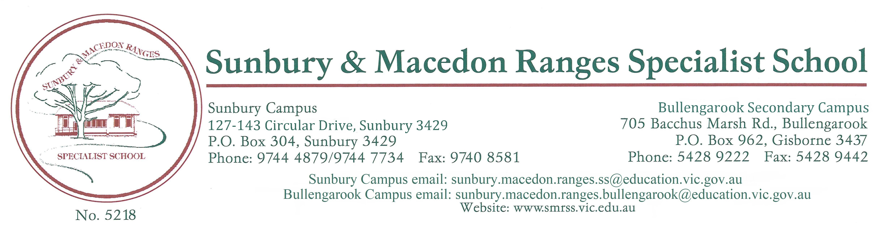

CLASS GROUPING POLICY
STATEMENT:
Sunbury and Macedon Ranges Specialist School is committed to the provision of a safe and supported learning environment. We place a high level of importance on ensuring and having the best possible system to form class groupings.

RATIONALE:
- To develop a clear mechanism for the placement of students into classes in order to maximise academic and learning opportunities, social competencies as well as positive working relationships.
- To form well balanced classes of students that consider the student’s age, social emotional, academic and personal support needs (which include may medical and / or mobility).
- Through collaboration of current teachers, parents and other specialist staff we will ensure that prior knowledge is applied to ensure the optimum placement of each child.

IMPLEMENTATION:
- The allocation of student classes, the number of classes, class structures and class compositions are all ultimately responsibilities of the Principal in collaboration with the school’s consultative committee. Drafts are reviewed in consultation with staff at leadership and subschool meetings
- The process of determining classes will commence during term 4 of the previous year.
- When class groupings are finalised, the Principal will call for expressions of interest from staff to teach each group.
- Individual needs and a whole school perspective must be considered when determining class groupings.
- Under exceptional circumstance the Principal may reorganize classes throughout the year.
- Class groupings will be reviewed by the Leadership team at the end of Term 1 each year.
- Every effort will be made to provide parents with a finalised class list accompanied by student reports on the last day of Term 4.
- Students who enrol at the school or undertake a transition placement during the year may be temporarily placed in a class, with the possible need to alter the placement once further information regarding the child is known. In the absence of a suitable group, a student wanting to enrol after the start of the school enrolment may be delayed.
- Concerns regarding the placement of specific students in classes or the overall structure of classes must be directed in writing to the Principal.
EVALUATION:
Created date | May 2023
Consultation | School council
Endorsed by | Principal: Joanne Nolan …………………………………….  School Council President: Amanda Solarino ……………………………….
Endorsed on | May 2023
Next review date | Four - year cycle March 2027

