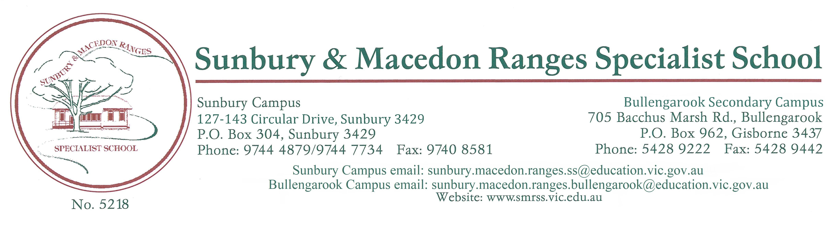

COMMUNICATION POLICY
STATEMENT:
Staff, parents and the wider school community have a mutual obligation to communicate effectively with each other to enhance educational outcomes for all students, as well as, the collective wellbeing of the school community. The Communication Policy is relevant to all program procedures operating throughout the school.
RATIONALE:
Our school has a policy of open and cooperative communication.
- To ensure that the communication of information is carried out correctly and in a manner that complies with school, departmental and legal requirements.
- To clearly define communication practices within the school community
- To keep the school community informed of decisions and processes designed to cater for the needs of individual students
- To ensure effective and efficient communication processes is established between the home, the school and service providers.
- To ensure parents are kept informed of student progress
- To establish a process for keeping parents informed of issues that significantly impact on the welfare of their child and others.
IMPLEMENTATION:
Guidelines-
- To ensure civility and the observance of fundamental etiquettes of communication are observed at all times.
- To ensure forums for discussion and resolutions of educational, medical, therapeutic and behavioural matters are clearly established
- To ensure strategies and Individual Education Plans (IEP’s) are developed to address the educational and social needs of the child.
- To establish effective communication pathways between staff and the school community which will be communicated to parents and the school community at the beginning of each school year and will be achieved in the following ways:
Daily Communication
The daily communication book/diary is the primary medium of communication with the school. Parents will be advised that any queries should, in the first instance, be raised with the classroom teacher for consideration. Sensitive or personal matters can be directed to the Campus Principal, Assistant Principals and Sub School Leaders.

Weekly Communication
The Chronicle (School Newsletter) is published each Friday and is also available via XUNO and the school’s webpage. It contains classroom reports, recognition awards, information about up and coming events at school and news of major DET initiatives.
XUNO
Periodically XUNO (a secure online app that can be used for two-way communication between the school and student families) may be used for parents and teachers, therapists, as well as members of the Leadership team to communicate during working hours.
Term Curriculum Summaries and timetables
Individual Curriculum Summaries and timetables will be forwarded to parents in the second week of each term.
Student Support Group Meetings
Parents are invited to a “Meet the Teacher Night” in Term One of each year to consolidate the Students’ Individual Learning Plan. The ILP includes program goals and priorities for the year. At the fourth/fifth week of Terms Two and Three, a student review is held, either through an appointed meeting with the teacher or a discussion over the phone.
A midyear report will be forwarded to parents at the end of Term Two, reporting progress toward the mastery of goals listed in the Individual Learning Plan.
An end of year report night will be held in early December for parents and teachers to review student progress (inclusive of Therapy and specialist reports) and determine priorities for the following year.
Parent Forums
Parent forums will be conducted. These forums have an information sharing focus and are usually attended by a guest speaker who is invited along to address the group on common interest issues.
Individual Appointments
Parents will be advised that individual appointments can be organized with classroom teachers via the communication book or by contacting the Sub School Leaders. These will be conducted at a mutually convenient time to minimize disruption to classroom programs.
Annual Events (Whole School Community Activities)
A number of regular annual events will be conducted to which our entire community will be invited:
- Education Week Open Days
- School theatrical production (biannually)
- Whole School Family Picnic
- Christmas Extravaganza
- Footy Day.
Unscheduled visits to classes.
Parents will be advised that unscheduled visits to classes must be kept to a minimum (unless in the event of an emergency). They can be disruptive to a program and unnecessarily break the concentration of the group.
Parents are welcome to visit the school and for safety and security reasons we ask that they report to the office, sign in and wear a visitor’s badge. Visits to classes outside of school grounds require Working with Children’s Check permits and prior individual arrangements need to be made with the class teacher.
Staff are generally available for phone calls either before classes commence (before 9.00am) and after classes finish (after 3.00pm).

Positive Behaviour Support
Positive Behaviour Support meetings will be responsible for monitoring student behaviour and welfare issues.
The PBS meetings discuss individual behavioural management issues and develops draft agreed behavioural management plans in consultation with parents and guardians where indicated. A register of incident reports is also maintained at each campus. These incident reports will be forwarded to parents of students involved in behavioural incidents.
When behaviour presents a concern to the health and safety of other students, staff, or members of the community the principal or nominee will contact families to convene an extraordinary program support group to attempt to develop an agreed behavioural management plan to manage and extinguish the behaviour.
Communication guidelines pertaining to School Operation
At Sunbury and Macedon Ranges Specialist School we subscribe to collaborative and consultative leadership practices as a means of empowering all members of staff thereby improving student educational outcomes, resolving conflict and enhancing team spirit.

REFERENCES:

DET School Communications Toolkit 2020
- SMRSS School Student Engagement and Well Being Policy 2017.
- DET School Policy and Advisory Guide – Reporting Student Assessment Results.
- SMRSS Working with Children’s Check Policy 2017
- SMRSS Camps and Excursion Policy 2019
- SMRSS Community Access Policy 2017

DET School Operations updates
EVALUATION
- This policy will be reviewed as part of the school’s three-year review cycle.

THIS POLICY HAS BEEN RATIFIED BY SCHOOL COUNCIL

Joanne Nolan ……………………… Mark Davies ……………………..
Principal President of School Council

Date: 28/10/2020………………. Review due: 28/10/2023……………………

