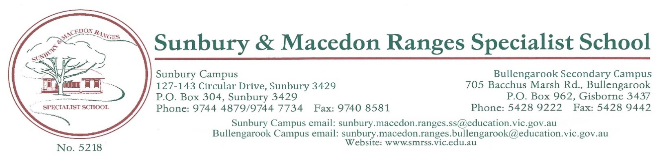

s

VISITORS POLICY

Purpose:
To provide a safe and secure learning and teaching environment for students and staff by establishing processes to monitor and manage visitors to Sunbury and Macedon Ranges Specialist School.

Scope:
This policy outlines our school’s arrangements for visitors who attend school grounds when the school is open for instruction between the hours of 9:00 am to 3:00pm.The office is generally staffed between the hours of 8:00 – 4:00pm.

DEFINITIONs:
Child-related work: As defined by the Worker Screening Act 2020 (Vic), child-related work is work that usually involves direct contact (including in person, over the phone, written and online communication) with a child that is a central part of that person’s duties. It does not include work that involves occasional direct contact with children that is incidental to the work.

Policy :
Sunbury and Macedon Ranges Specialist School strives to create an open and inclusive school community, and encourages parents and carers to be actively involved in their child’s development and education. We also strive to foster strong partnerships with local community services, schools and other organisations.
Sunbury and Macedon Ranges Specialist School is not a public place. The principal has the authority to permit or deny entry to school grounds, and encourages all visitors to familiarise themselves with our school’s Statement of Values, Child Safety Policy, Child Safety Code of Conduct, Volunteers Policy
From time to time, different members of the public may visit our school. Visitors may include, but are not limited to:
- Parents
- Volunteers – see our school’s Volunteers Policy for more information
- Prospective parents, students and employees
- Invited speakers, sessional instructors and others addressing learning and development
- Public officials (e.g. Members of Parliament, local councillors)
- Persons conducting business (e.g.: uniform suppliers, booksellers, official schools0
- Tradespeople
- Children’s services agencies
- Department of Families, Fairness and Housing workers
- Victoria Police
- Persons authorised to enter school premises (e.g. Worksafe inspectors, health officers, film crews etc)
- Other Department of Education and Training staff (including allied health staff) or contractors
- NDIS therapists or other allied health or health practitioners

Sign in procedure
All visitors to Sunbury and Macedon Ranges Specialist School are required to report to the school office on arrival. Visitors must:
- Record their name, signature, date and time of visit and purpose of visit via the PASS TAB iPad
- Provide proof of identification to office staff upon request
- Produce evidence of their valid Working with Children Clearance where required by this policy (see below)
- Follow instruction from school staff and abide by all relevant school policies relating to appropriate conduct on school grounds including eg: Child Safety Code of Conduct, Statement of Values as well as Department policies such as the Sexual Harassment Policy and Workplace Bullying Policy
- Return to the office upon departure, sign out via the PASS TAB iPad
Sunbury and Macedon Ranges Specialist School will ensure that our school’s Child Safety Code of Conduct is available and visible to visitors when they sign in.
COVID-19 vaccination information
Our school follows Department of Education and Training policy with respect to the requirements relating to attendance on school sites and COVID-19 vaccinations.
For further information, refer to:
- COVID-19 Vaccinations – Visitors and Volunteers on School Sites
Working with Children Clearance and other suitability checks
For Working with Children (WWC) Check and other suitability check requirements relating to Parent/cares and other volunteers working with students please see our Volunteer policy
All visitors who are engaged in child-related work (see definition above) must have a valid WWC Clearance. Additional suitability checks may also be required such as reference, proof of identity, qualification and work history involving children checks.
In some circumstances, visitors to Sunbury and Macedon Ranges Specialist School who are not engaged in child-related work will also be required to produce a valid WWC Clearance depending on the particular circumstances of their visit. For example, Sunbury and Macedon Ranges Specialist School will require a valid WWC Clearance for:
- visitors who will be working regularly with children during the time they are visiting, even though direct contact with children is not a central part of their normal duties
- visitors (e.g. contractors), who will regularly be performing unsupervised work at the school during school hours or any other time where children are present. Further background checks, including references, may also be requested at the discretion of the principal.
- Visitors who will be working in areas away from students (e.g. a visiting auditor who will be located in the front office with administration staff) or who will be supervised and accompanied by a staff member during their visit (e.g. a Member of Parliament, a journalist, a prospective parent on a school tour) will not be required to have a WWC Clearance.
- Sworn Victoria Police officers or sworn Australian Federal Police officers are exempt from requiring a WWC Check, but may be asked to verify that they are sworn officers by providing proof of identification.

Invited speakers and presenters
On occasion, Sunbury and Macedon Ranges Specialist School may invite external speakers or providers to deliver incursions, presentations, workshops and special programs for our students. Consistent with Department of Education and Training requirements, Sunbury and Macedon Ranges Specialist School will:
- ensure that the content of presentations and programs by external providers contributes to the educational development of our students and is consistent with curriculum objectives
- ensure that any proposed visit, programs or content delivered by visitors complies with the requirement that education in Victorian government schools is consistent with the values of public education, Department policies and the Education and Training Reform Act 2006 (Vic). In particular, programs delivered by visitors are to be delivered in a manner that supports and promotes the principles and practice of Australian democracy including a commitment to:
  - elected government
  - the rule of law
  - equal rights for all before the law
  - freedom of religion, speech and association
  - the values of openness and tolerance
  - respect for the range of views held by students and their families.

Parent visitors
All parents or carers who visit our school during school hours, other than for the purposes of school pick ups and drop offs or for specific school events (eg parent teacher interviews, concerts, assemblies etc), are required to sign in as a visitor at the school office.
Parents or carers who are prohibited from entering the school under a court order or direction of the Principal are not permitted to visit the school.

Other visitors

All business operators, tradespeople and other visitors attending the school to conduct work must report to the school office upon arrival for instruction and follow the sign in procedure outlined above.
COMMUNICATION
This policy will be communicated to our school community in the following ways
- Available publicly on our school’s website
- Included in induction processes for relevant staff
- Included in our staff manual
- Discussed in an annual staff briefing/meeting
- Made available in hard copy from school administration upon request

Related policies and resources
Sunbury and Macedon Ranges Specialist School policies and resources relevant to this policy include:
- SMRSS Values
- SMRSS Volunteer Policy
- SMRSS Child Safe and Wellbeing Policy
- SMRSS Child safety Code of Conduct
- SMRSS Child Safety Responding and Reporting Obligations Policy and Procedures,
- SMRSS Sunbury and Macedon Ranges Specialist School Child Safety Induction Pack
- SMRSS Inclusion and Diversity Policy
Department policies:
- Child Safe Standards
- Visitors in Schools
- Contractor OHS Management

Policy Review and approval
Created date | June 2022
Consultation | School council
Endorsed by | Principal: Joanne Nolan …………………………………….  School Council President: Amanda Solarino ……………………………….
Endorsed on | August 2022
Next review date | Two-year cycle August 2024

